0000000000000000

Registrazione dei dati

|  |  |  |
| --- | --- | --- |
| ind | dato | commento |
| 001 | A |  |
| 002 | B |  |
| 003 | C |  |
| 004 | X |  |
| 005 | A*X |  |
| 006 | A*X+B |  |
| 007 | X*(A*X+B) |  |
| 008 | Y=X*(A*X+B)+C |  |

Registrazione del programma

|  |  |  |  |  |  |
| --- | --- | --- | --- | --- | --- |
| ind | Cod.op | Arg.1 | Arg.2 | Arg.3 | commento |
| 100 | 3 | 001 | 004 | 005 | A*X |
| 101 | 1 | 005 | 002 | 006 | A*X+B |
| 102 | 3 | 006 | 004 | 007 | X*(A*X+B) |
| 103 | 1 | 003 | 007 | 008 | Y=X(A*X+B)+C |

**ESEMPIO: Programma per calcolare**

**Y = A×X2 + B×X + C = (A×X + B) ×X + C, per X, X+H, X+2H, …, Xmax.**

|  |  |  |  |  |  |  |  |
| --- | --- | --- | --- | --- | --- | --- | --- |
| **ind** | **c.op** | **0perando** | **next** | **operazione** | **commento** | **Upper-8003** | **Lower-8002** |
| **====** | **=** | **====** | **===** | **======** | **========** | **======** | **=======** |
| **0000** | **60** | **0003** | **0007** | **ResetAddUpper** | **X in Upper** | **X** |  |
| **0007** | **21** | **0027** | **0030** | **Store Upper** | **<upper> in 0027** | **X** |  |
| **0030** | **19** | **0033** | **0004** | **MPY** | **<33>*<upper>** |  | **A*X** |
| **0004** | **15** | **0057** | **0011** | **AddLower** | **<57>+<lower>** |  | **A*X+B** |
| **0011** | **60** | **8002** | **0019** | **RAU** | **Lower in Upper** | **A*X+B** |  |
| **0019** | **19** | **0027** | **0048** | **MPY** | **<27>*<upper>** |  | **(A*X+B)*X** |
| **0048** | **15** | **0001** | **0005** | **AddLower** | **<01>+<lower>** |  | **(A*X+B)*X+C** |

# Babbage: la macchina analitica per eseguire sequenze delle quattro operazioni.

[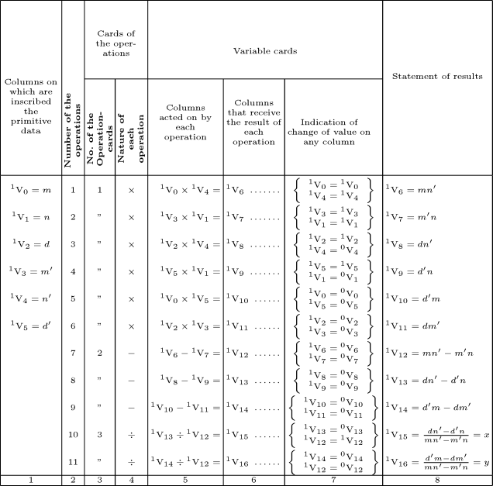](../AppData/Local/Microsoft/Windows/Temporary%20Internet%20Files/Low/Content.IE5/FLHMENDB/figures/menat3_l.png)**Esempio di programma descritto nell’articolo di Menabrea.**